Autobahn Topology Builder
User Guide
Author: Lucas Dolata

Spis treści
Tool description 3
About user guide 3
Main window 3
Step by step tutorial 4
Creating project 4
Managing project elements 5
Adding nodes 5
Adding interfaces for node 6
Adding link between two interfaces 7
Adding VLANs for a link(Only Ethernet specific topology) 7
Storing project 8
Export topology to IDM format 8
Import topology to Autobahn Topology Builder Project 8

Tool description
Autobahn Topology Builder have been developed for the purposes of GEANT2 JRA3 activity. Application help building topology configurations for the Domain Manager of Autobahn Bandwidth on Demand Service. It provides user friendly GUI interface, which supports building two kinds of topology:
- Ethernet
- SDH

About user guide
The purpose of this document is to learn how easy and fast build topology for Domain Manager with Autobahn Topology Builder. This document provides step by step description how to:
- create new project,
- add elements of the topology
- save project
- export topology to format accepted by Autobahn infrastructure.

Main window
In this section we provide short overview of Autobahn Topology Builder components. Main window of Autobahn Topology Builder is shown below:
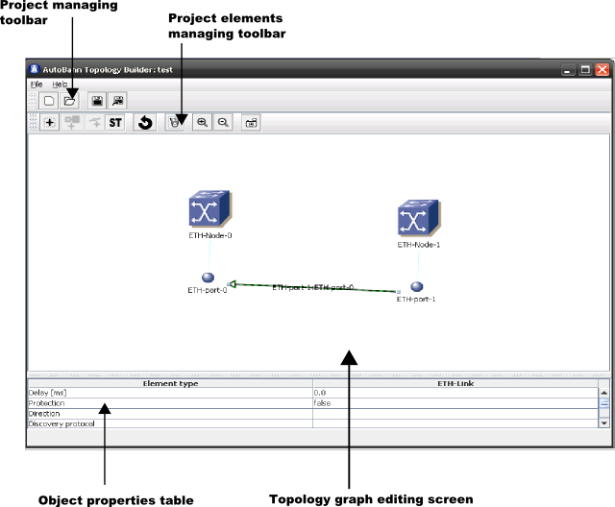
The windows is composed of following parts:
Project managing toolbar – Toolbar allows to create new, open existing, save project and export created topology to Domain Manager style.
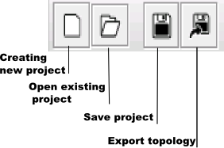
Project elements managing toolbar- Toolbar allows adding, removing elements of topology, zooming in and out on the graph screen , making snapshot of the screen.

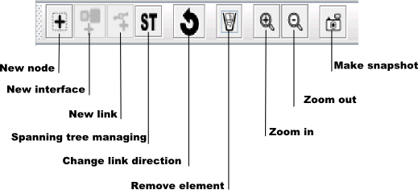

Topology graph editing screen – The screen allows create ordered view of a topology. Nodes, lines are represented by graphical object which can be move across the screen.
Object properties table – The table allows setting attributes for chosen on the Topology editing screen object.

Step by step tutorial

Creating project
To start work on building topology for Autobahn services first You should create project. You can create new project by choosing option New Project from File menu, by pressing Alt+N key combination or by pressing button on the Project managing toolbar.
After that New widow will appear. This window allow you to change name, type and directory where you can save project description.
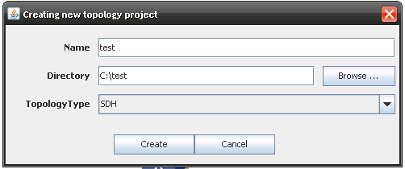
You can chose two different types of project SDH and Ethernet, to create valid topology for your needs.
I our tutorial we have chosen a Ethernet base topology. This kind of topology is more complicated. Almost all steps made in this tutorial should be made also in SDH type also.

Managing project elements
After creating new project you can start real work.

Adding nodes
As first step we should add some nodes to our topology. On the Project elements managing toolbar You will see four active icons. The most important for now is first icon . When you click on this icon you will see that on the center of the Topology graph editing screen appear a blue cube witch label ETH-Node-0. This cube represents our first node in topology. Now we must set some properties for this node. Select node by clicking once on the blue icon. Bellow the Topology graph editing screen is located Object properties Table. It looks as follows:
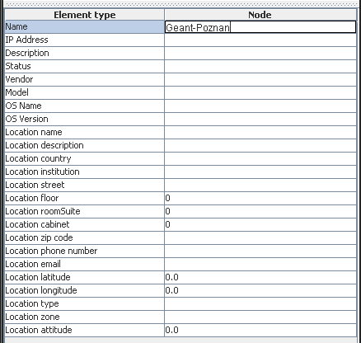
To change property you must click twice on the property value(property row and second column) and provide new value. After editing press Enter key. In some cases you must provide valid value type, for example number. If you put wrong and confirm by enter value will return to previous value.
Please try to change some properties, for example name. Then move icon to other place on the screen.
After that add some extra nodes and set their properties. In next section you should at least two nodes.

Adding interfaces for node
To add interface for a created node you must first select the node icon on the Topology graph editing screen. This activates new icon on the Project Elements Managing Toolbar. ( ). To add interface for node you need only click on this icon. As you see bellow created interface is represented by ball icon. The interface is connected to its owner node by thin and green line. This line is only used for presentation of the node and interface relation.
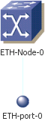
The main hint for creating new interfaces for nodes is to know different its types Bellow is shown diagram with example:
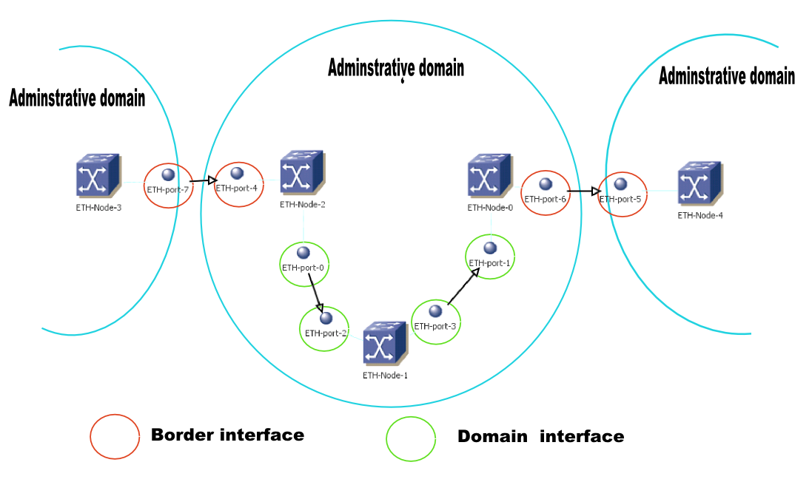
As you can see there are two types of interfaces:
Border interface – this interface is stitching point between two different administrative domains. When you define the border interface you must set the property Domain Identifier. The value of setting property should be URL to IDM of Administrative domain. For example
Domain identifier = https://poznan.autobahn.psnc.pl:8443/autobahn-idm/
Domain interface- this interface is use internal in domain. You define interface as Domain interface by leaving the property Domain identifier empty.
Setting interface properties look the same as setting node properties. You need to select a interface by clicking on its icon. Then you can change properties value on Object Properties Table.

Adding link between two interfaces
To add link between two interfaces you should first select two interfaces by holding SHIFT key and clicking on icons of interfaces. The order of a selecting is important. A first of selected interfaces will always be the starting point of the link/ On the Project elements managing toolbar appear new button . Click on this button and new link will be added between to interfaces. You should see following:
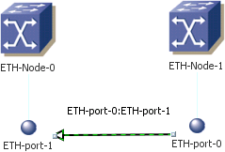
Link is represented by black arrow. The arrow shows orientation of the link. On the screen you can see that ETH-port-0 is start point and ETH-Port-1 is the target point. You can change direction of a link by clicking on line and pressing new appear button This will automatically change start and end point of the link.

Adding VLANs for a link(Only Ethernet specific topology)
Adding VLAN is only allowed in Ethernet specific project. For the SDH specific project this action is disabled. To add VLAN for link you must select the link on the Topology graph editing screen. After it on the Project elements managing toolbar appear button . Click on this button. New window appears on the screen. This window allows managing VLANs and spanning tree for link.
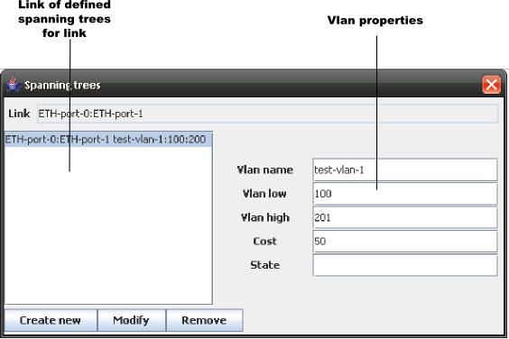
With this window you can add, modify and remove VLANs related with selected link. After changing VLANs state you can simply close this window and revoke it each time you want to change configuration.

Storing project
To store the project information on a disk you can choose from the File menu one of the Save options (Save or Save as) or click the icon . All information about project including topology data and position of icon on the Topology graph editing screen will be store with saving.

Exporting topology to IDM format
To upload the topology to Autobahn IDM you must export topology to valid format. You need only to choose from File menu option Export topology or just click on the Project Managing toolbar the icon. You will have to choose file where you want to store the topology. Topology is XML based document.

Importing topology to Autobahn Topology Builder Project
The Autobahn Topology Builder allows also importing the topology from file in Autobahn IDM format. You need only choose from File menu option Import topology. Open Dialog appear. You can select file you want to import.
The Autobahn IDM topology format stores only information about Autobahn specific data without any attributes for icon’s position on the Topology graph editing screen. So if you import this kind of topology you will see probably disordered icons. You can order them and then save as Autobahn Topology Builder project.

